Sr. No | Photo | Name | Designation | Exp. | Qualification | Email id | Date Of Joining | Nature Of Association | Profile
8. | 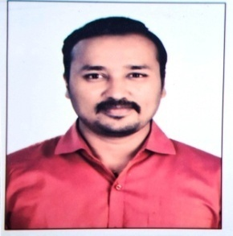 | Mr. Ashish Bharat Kalekar | Lecturer | 2 Yrs | B.E in Automobile Engineering | akalekar516@gmail.com | 01.08.2025 | Adhoc  (Full-Time)
9. | 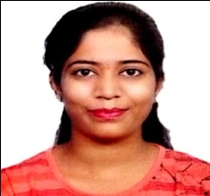 | Mrs. Priyanka Tukaram Kankhare | Lecturer | 4 Yrs | BE Mechanical | priyankakankhare@gmail.com | 11.09.2025 | Adhoc  (Full-Time)
Staff details of Mechanical Engineering Department for Web Site

